 | SR UNIVERSITY  Campus Warangal
 | Program: II - B. Tech (CS& AI) Batch: 2025 – 2029
Name:MOHAMMAD AFNAN AHMED KHAN
Reg. No:2503A52310
 | Department: Computer Science and AI Semester: I
 | AI Assisted Coding – Assignment: 12 Date: 23-09-2026

Q1 – AI-Assisted Bubble Sort Analysis
Question:
- Given numbers = [64, 34, 25, 12, 22, 11, 90], implement Bubble Sort in ascending order.
- Count the number of comparisons and swaps made while sorting.
- Test the algorithm on at least three input lists and compare an early-exit optimised version against the original.
Prompt (used with the AI assistant):
"Explain one complete pass of Bubble Sort on [64, 34, 25, 12, 22, 11, 90], then show me how to add an early-exit optimisation that stops the algorithm once no swaps occur in a pass."
Code:
def bubble_sort(arr):
arr = arr.copy()
n = len(arr)
comparisons = 0
swaps = 0
for i in range(n - 1):
for j in range(n - 1 - i):
comparisons += 1
if arr[j] > arr[j + 1]:
arr[j], arr[j + 1] = arr[j + 1], arr[j]
swaps += 1
return arr, comparisons, swaps

def bubble_sort_optimised(arr):
arr = arr.copy()
n = len(arr)
comparisons = 0
swaps = 0
for i in range(n - 1):
swapped = False
for j in range(n - 1 - i):
comparisons += 1
if arr[j] > arr[j + 1]:
arr[j], arr[j + 1] = arr[j + 1], arr[j]
swaps += 1
swapped = True
if not swapped:
break # early-exit optimisation
return arr, comparisons, swaps

test_lists = [
[64, 34, 25, 12, 22, 11, 90],
[1, 2, 3, 4, 5],
[5, 4, 3, 2, 1],
]

for lst in test_lists:
sorted_arr, cmp, sw = bubble_sort(lst)
print(f'Input: {lst}')
print(f' Original: {sorted_arr} comparisons={cmp}, swaps={sw}')
sorted_arr2, cmp2, sw2 = bubble_sort_optimised(lst)
print(f' Optimised: {sorted_arr2} comparisons={cmp2}, swaps={sw2}')
Output:
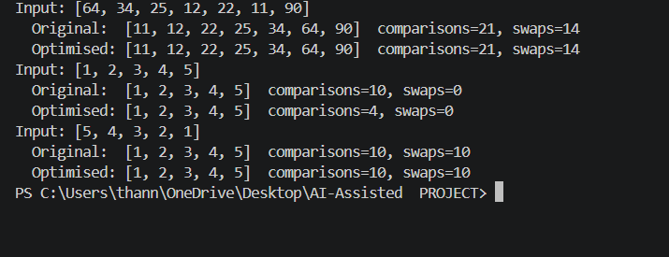
Observation:
- Both versions sort every list correctly and produce the same final output.
- On the already-sorted list [1,2,3,4,5], the optimised version needed only 4 comparisons and made one pass instead of the original's 10 comparisons across 4 passes — the early-exit check (swapped flag) detects a fully sorted array immediately.
- On the reverse-sorted list [5,4,3,2,1], every pass still performs at least one swap, so the optimised and original versions perform identically (10 comparisons, 10 swaps) — the early exit only helps when the data becomes sorted before the last pass.
- Time complexity remains O(n²) in the worst case for both versions; the optimisation improves the best case to O(n) for already-sorted input.
Q2 – Linear Search vs Binary Search
Question:
- Given numbers = [5, 12, 18, 23, 31, 45, 56, 72, 89] and target = 45, implement Linear Search and Binary Search.
- Count the number of comparisons made by each algorithm.
- Test both algorithms for the first, middle, last, and an absent element.
Prompt (used with the AI assistant):
"Explain why Binary Search requires the input array to be sorted, and suggest a way to reduce comparisons in Linear Search for an already-sorted array."
Code:
def linear_search(arr, target):
comparisons = 0
for i, val in enumerate(arr):
comparisons += 1
if val == target:
return i, comparisons
return -1, comparisons

def binary_search(arr, target):
comparisons = 0
low, high = 0, len(arr) - 1
while low <= high:
mid = (low + high) // 2
comparisons += 1
if arr[mid] == target:
return mid, comparisons
elif arr[mid] < target:
low = mid + 1
else:
high = mid - 1
return -1, comparisons

numbers = [5, 12, 18, 23, 31, 45, 56, 72, 89]
targets = {'first (5)': 5, 'middle (31)': 31, 'last (89)': 89,
'absent (100)': 100, 'assignment target (45)': 45}

for label, t in targets.items():
li, lc = linear_search(numbers, t)
bi, bc = binary_search(numbers, t)
print(f'{label}: Linear -> index {li}, cmp {lc} | Binary -> index {bi}, cmp {bc}')
Output:
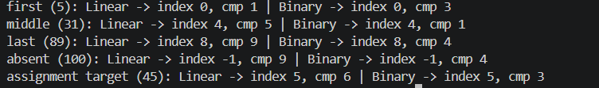
Observation:
- Linear Search performs well only when the target is near the start (1 comparison for the first element) but degrades to O(n) for the last element or an absent element (9 comparisons on a 9-element list).
- Binary Search needs at most ⌈log2(9)⌉ = 4 comparisons for any case, including the absent element, because it eliminates half the search space at every step.
- Binary Search requires sorted data because its decision to move left or right depends on comparing the middle element against the target — this only correctly narrows the range when the array is ordered.
- For small or unsorted, frequently-changing data, Linear Search is simpler and avoids the cost of sorting; for large, static, sorted datasets, Binary Search is clearly superior (O(log n) vs O(n)).
Q3 – Compare Sorting Algorithms
Question:
- Given data = [45, 12, 78, 34, 23, 89, 5, 67, 10, 56], sort it using Bubble Sort, Selection Sort, and Insertion Sort.
- Use the same input for all three algorithms and count comparisons and swaps/shifts.
- Compare the experimental results with the theoretical time complexity of each algorithm.
Prompt (used with the AI assistant):
"Compare Bubble Sort, Selection Sort, and Insertion Sort on this dataset — explain their strengths, weaknesses, and which one is best suited for nearly-sorted data."
Code:
def bubble_sort(arr):
arr = arr.copy(); n = len(arr); cmp = 0; sw = 0
for i in range(n - 1):
for j in range(n - 1 - i):
cmp += 1
if arr[j] > arr[j+1]:
arr[j], arr[j+1] = arr[j+1], arr[j]; sw += 1
return arr, cmp, sw

def selection_sort(arr):
arr = arr.copy(); n = len(arr); cmp = 0; sw = 0
for i in range(n - 1):
min_idx = i
for j in range(i + 1, n):
cmp += 1
if arr[j] < arr[min_idx]:
min_idx = j
if min_idx != i:
arr[i], arr[min_idx] = arr[min_idx], arr[i]; sw += 1
return arr, cmp, sw

def insertion_sort(arr):
arr = arr.copy(); n = len(arr); cmp = 0; sh = 0
for i in range(1, n):
key = arr[i]; j = i - 1
while j >= 0:
cmp += 1
if arr[j] > key:
arr[j+1] = arr[j]; sh += 1; j -= 1
else:
break
arr[j+1] = key
return arr, cmp, sh

data = [45, 12, 78, 34, 23, 89, 5, 67, 10, 56]
for name, fn in [('Bubble Sort', bubble_sort),
('Selection Sort', selection_sort),
('Insertion Sort', insertion_sort)]:
sorted_arr, cmp, sw = fn(data)
print(f'{name}: {sorted_arr} comparisons={cmp}, swaps/shifts={sw}')
Output:
Observation:
- All three algorithms correctly produce the sorted list [5, 10, 12, 23, 34, 45, 56, 67, 78, 89].
- Selection Sort made the fewest swaps (6) because it performs exactly one swap per pass, while Bubble Sort and Insertion Sort made 24 swaps/shifts each — Selection Sort minimises writes at the cost of always scanning the full remaining array.
- Insertion Sort made the fewest comparisons (31) versus 45 for both Bubble Sort and Selection Sort, since it can stop scanning early once it finds the correct insertion point.
- All three are O(n²) in the worst case, matching the theoretical complexity confirmed by the similar comparison counts here (10-element input).
- Insertion Sort is the best choice for nearly-sorted data, since its comparisons drop toward O(n) when few elements are out of place — this matches its early-exit inner while loop.
Q4 – Optimising a Student Search and Sort Program
Question:
- Given a list of (name, mark) tuples for 5 students, write functions to find the highest mark, sort students by mark, and search for a student by name.
- Start with a straightforward solution, then use AI to identify unnecessary operations and suggest a more efficient approach.
- Compare the original and improved solutions' time complexity.
Prompt (used with the AI assistant):
"Review this code for finding the highest mark and searching a student by name — are there any unnecessary operations, and how can I make these functions more efficient?"
Code:
students = [
('Arun', 82), ('Bala', 65), ('Chitra', 91),
('Divya', 74), ('Esha', 88)
]

# Straightforward (unoptimised) versions
def highest_mark_v1(students):
sorted_students = sorted(students, key=lambda s: s[1], reverse=True)
return sorted_students[0] # O(n log n) just to find one max

def sort_by_mark_v1(students):
return sorted(students, key=lambda s: s[1])

def search_by_name_v1(students, name):
for s in students:
if s[0] == name:
return s
return None # O(n) linear scan

# AI-suggested improved versions
def highest_mark_v2(students):
return max(students, key=lambda s: s[1]) # O(n)

def search_by_name_v2(students_dict, name):
return students_dict.get(name) # O(1) average

print('Highest (v1):', highest_mark_v1(students))
print('Highest (v2):', highest_mark_v2(students))
print('Sorted by mark:', sort_by_mark_v1(students))
print("Search 'Chitra' (v1):", search_by_name_v1(students, 'Chitra'))
students_dict = dict(students)
print("Search 'Chitra' (v2):", search_by_name_v2(students_dict, 'Chitra'))
print("Search 'Zara' (absent):", search_by_name_v1(students, 'Zara'))
Output:
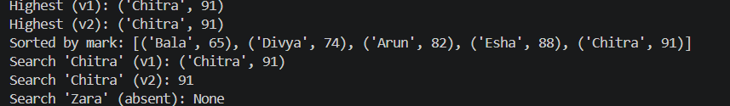Observation:
- The straightforward highest_mark_v1() sorts the entire list (O(n log n)) just to read off the first element; the AI-suggested highest_mark_v2() uses Python's built-in max() to scan once in O(n) — both return the same correct result, ('Chitra', 91), but the improved version does less work.
- search_by_name_v1() scans the list linearly (O(n)) and correctly returns None for an absent name ('Zara'); search_by_name_v2() converts the list to a dictionary once and performs an O(1) average-time lookup, which is more efficient when many repeated searches are needed.
- Sorting by mark (sort_by_mark_v1) is already close to optimal at O(n log n) using Python's Timsort, so no further improvement was suggested there.
- Overall, the improved solution trades a small one-time cost (building the dictionary) for much faster repeated lookups — a good trade-off whenever search_by_name is called more than once.
Q5 – Optimisation Challenge: Best Combination
Question:
- Given a list of items with prices and a budget of ₹50,000, find the combination of items with the highest total price that does not exceed the budget.
- Compare Brute Force, Greedy, and Dynamic Programming approaches and determine which guarantees an optimal solution.
- Implement the selected approach and test it with at least three different budgets.
Prompt (used with the AI assistant):
"Compare Brute Force, Greedy, and Dynamic Programming approaches for this 0/1 knapsack-style budget problem, and tell me which one guarantees the optimal answer."
Code:
from itertools import combinations

items = [('Laptop', 60000), ('Phone', 30000), ('Tablet', 20000),
('Watch', 10000), ('Headphones', 5000)]

def brute_force_best_combo(items, budget):
best_combo, best_total = [], 0
for r in range(1, len(items) + 1):
for combo in combinations(items, r):
total = sum(p for _, p in combo)
if total <= budget and total > best_total:
best_total, best_combo = total, combo
return best_combo, best_total # O(2^n)

def dp_best_combo(items, budget):
n = len(items)
dp = [[0] * (budget + 1) for _ in range(n + 1)]
for i in range(1, n + 1):
name, price = items[i - 1]
for b in range(budget + 1):
dp[i][b] = dp[i - 1][b]
if price <= b:
dp[i][b] = max(dp[i][b], dp[i - 1][b - price] + price)
b, chosen = budget, []
for i in range(n, 0, -1):
if dp[i][b] != dp[i - 1][b]:
name, price = items[i - 1]
chosen.append((name, price)); b -= price
return list(reversed(chosen)), dp[n][budget] # O(n * budget)

for budget in [50000, 35000, 15000]:
combo_bf, total_bf = brute_force_best_combo(items, budget)
combo_dp, total_dp = dp_best_combo(items, budget)
print(f'Budget Rs.{budget}: BruteForce -> {combo_bf} = Rs.{total_bf}')
print(f' DP -> {combo_dp} = Rs.{total_dp}')
Output:
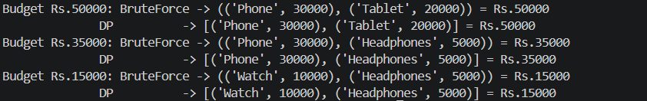Observation:
- A Greedy approach (e.g., always picking the most expensive item that still fits) is not used here because it can miss the true optimum — for example, greedily taking the Laptop (₹60,000) first is impossible under a ₹50,000 budget, and picking by 'value density' does not guarantee optimality for this 0/1 selection problem.
- Brute Force checks every possible subset (2⁵ = 32 combinations for 5 items) and is guaranteed optimal, but its O(2ⁿ) cost becomes impractical as the number of items grows.
- Dynamic Programming (0/1 knapsack) also guarantees the optimal answer, running in O(n × budget) time, which scales far better for larger item lists or larger budgets.
- For all three tested budgets (₹50,000, ₹35,000, ₹15,000), Brute Force and DP produced identical optimal combinations and totals, confirming the DP implementation is correct.
- DP is the recommended approach for larger inputs since it avoids the exponential blow-up of Brute Force while still guaranteeing the optimal combination, at the cost of extra memory for the DP table.

